

User Guide:
Stakeholder Insights and Performance Dashboard

Author Name | Created Date | Version | Last Updated
[Author Name] | [Created Date] | [Version] | [Last Updated]

User Guide: Stakeholder Insights and Performance Dashboard

Purpose:
The dashboard provides a comprehensive view of key business metrics and data insights related to stakeholders, insurers, and policy performance. It enables stakeholders to analyse premium trends, profitability, and asset distribution to make data-driven decisions.

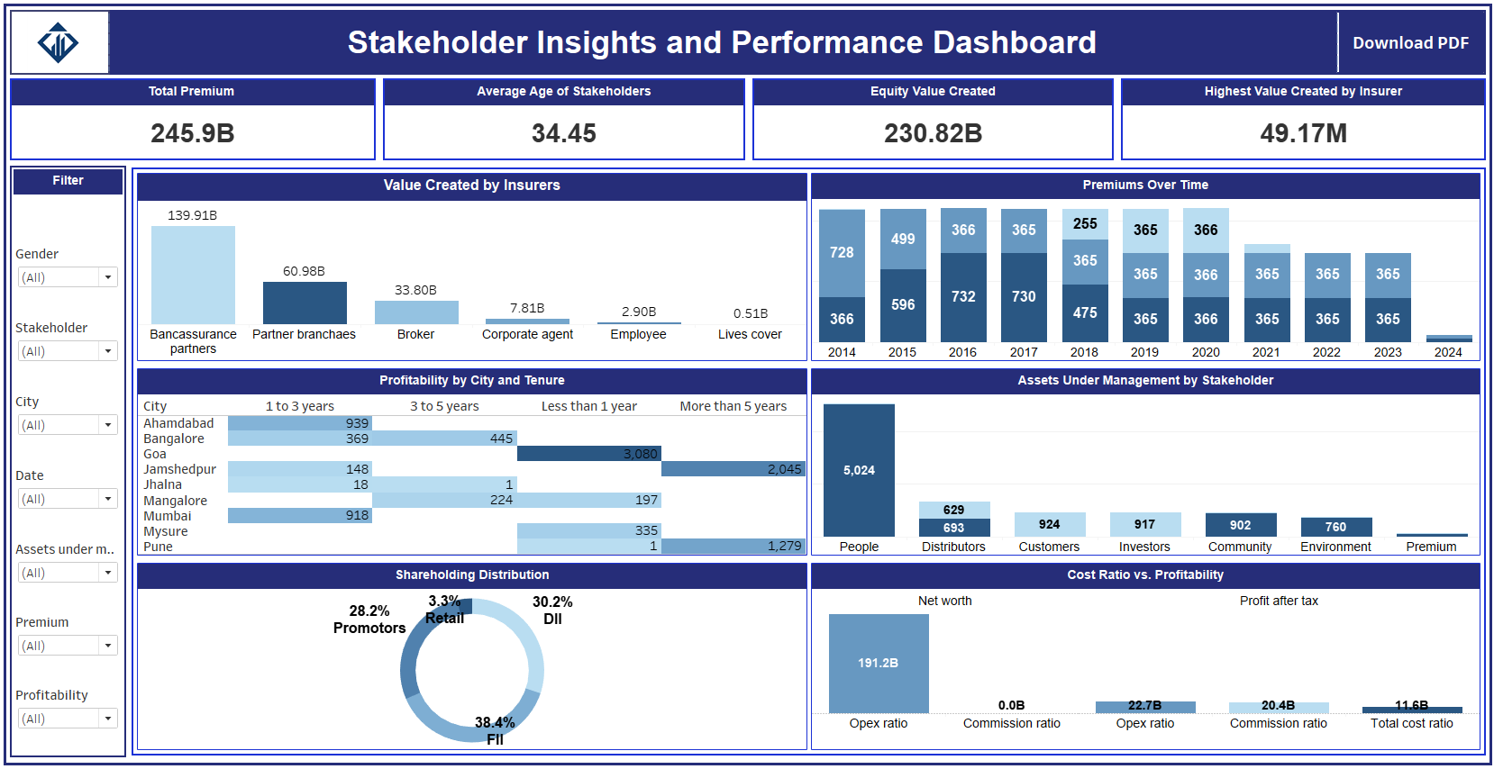
Requirements:
1. Charts and Visualizations:
- Compare the total value created by different insurers: Displays the total value created for a comparative analysis among insurers.
- Display trends in premiums collected over time: Shows premium trends using line or area charts to analyse changes over time.
- Showcase the distribution of shareholding patterns among stakeholders: Visualizes shareholding patterns using pie or bar charts.
- Analyse the relationship between cost ratio and profitability: Correlation or scatter plots reveal insights between cost ratio and profitability metrics.
- Visualize profitability for different cities and policy tenure durations: Heatmaps or bar charts categorize profitability by city and policy tenure.
- Represent the distribution of assets under management across stakeholders: Bar or treemap visualizations display how assets are distributed among stakeholders.

2. Key Performance Indicators (KPIs):
- Display the total premium collected: KPI card summarizing the total amount of premiums collected.
- Show the average age of stakeholders: KPI card presenting the average stakeholder age.
- Highlight the total Value Created for insurers or stakeholders where Assets under Management is 'Equity': KPI card focusing on value creation under equity management.
- Identify the highest value created by a single insurer: KPI card showcasing the top-performing insurer by value created.
3. Filters:
- Filter data by city: Dropdown menu to focus data visualization on specific regions.
- Filter data by stakeholders: Dropdown to isolate and analyze individual stakeholder contributions.
- Provide a range slider to filter policies based on tenure: Interactive slider to set tenure ranges.
- Allow filtering of data within a specific date range: Date picker to narrow data analysis to a desired timeframe.
- Enable filtering by gender for demographic insights: Gender filter to separate male and female stakeholder data.
4. Interactivity:
- Enable charts to dynamically filter other visuals when clicked: Clicking a chart segment applies filters to other dashboard elements.
- Provide tooltips on hover to display detailed information: Rich tooltips reveal additional context, such as specific values or percentages.
- Ensure filters and KPIs update dynamically based on selections: All dashboard elements refresh based on applied filters or clicks.
5. Export Options:
- PDF Export Button: Dedicated button to download the dashboard as a PDF.
- Ensure the PDF captures all visible charts, KPIs, and filters: Export captures a snapshot of the current dashboard state.
- Include a light watermark with the company's branding on the exported PDF: Branding ensures a professional and consistent look.
6. User Access:
- Role-based access: Stakeholders with different roles have specific levels of data visibility.

Usage Instructions:
Navigating the Dashboard:
- Use filters located at the top or side of the dashboard to refine data by city, tenure, date, stakeholder, or gender.
- Interact with charts by clicking on segments to dynamically update other dashboard visuals.
- Hover over any chart to view detailed tooltips for additional insights.
Exporting Data:
- Click the Export to PDF button located in the toolbar.
- Confirm the export options (e.g., filters and applied selections).
- The PDF file will include all visible elements, KPIs, and filters, along with a light watermark.
Accessing Role-Specific Data:
- Log in with your assigned credentials.
- Your role determines the data you can view (e.g., insurers, stakeholders, policy data).

Support and Contact:
For technical assistance or feedback, please contact the dashboard support team at support@companydomain.com.

